The Issue of the Shackling of the Psychosocially Disabled
Note: This is intended to only be an overview of the topic. Further research is required to gain a more detailed understanding.
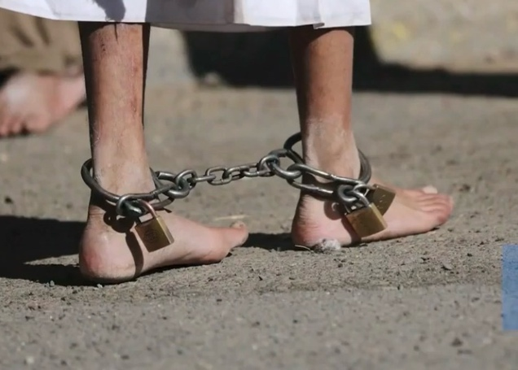

Globally, hundreds of thousands of people with psychosocial disabilities (mental health conditions) have been chained or locked in confined spaces. This is a common occurrence in over 60 countries, where individuals as young as 10 are restrained in inhumane conditions, such as sheds and cages for weeks, months, or even years at a time and are often forced to eat, sleep and urinate in the same place. Women and girls are not supported to manage their menstrual hygiene. The majority are held in non-medical settings: in government-run institutions, faith-healing centres, or in their own homes by their families due to stigma and a lack of provisions for those with mental health issues.
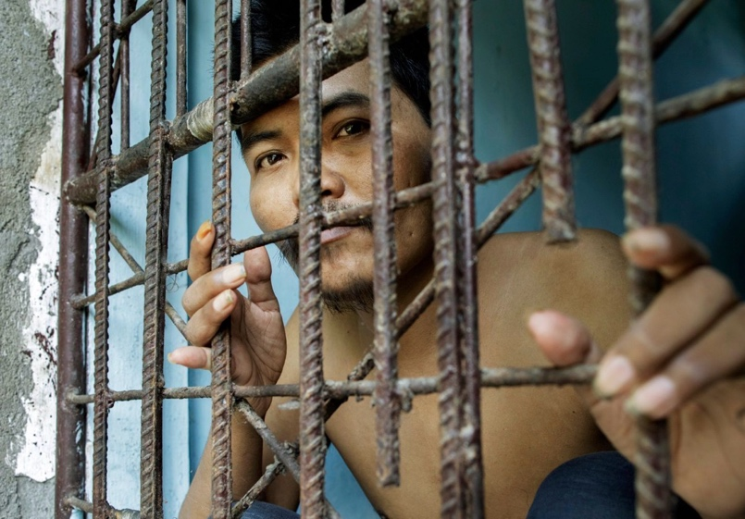
Shackling mostly takes place in developing nations in parts of Africa, Asia, and the Americas which have high poverty rates, and typically spend less than 2% of their yearly budgets on mental health. Decades of conflict in some of these areas have seen a rise in the number of those with psychosocial disabilities. It is practiced by families with little support from the state who believe that mental health conditions are as a result of an individual having sinned, or the presence of evil spirits, so are sent to ‘faith-healers’, where they end up chained in faith-healing centres. Here, people are subjected to alternative treatments, such as a concoction of herbs and vigorous massages, alongside medicine administered by inhumane means. Others feel they have no other option, due to the expense of medical treatments or the distance to hospitals. Shackling is considered to be the only option for families who are worried that their relative could hurt someone, or themselves.

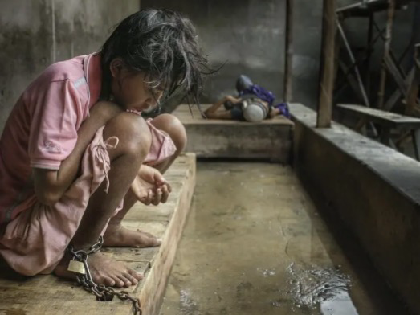
In many institutions, male staff are permitted to enter and leave the women’s ward, and were sometimes in charge of them, leading to an increased risk of sexual violence, as well as constant fear from the women. Men, women and children were sometimes chained next to each other, giving them no opportunity to escape if they were victims of abuse, from staff or other chained individuals.

Research has shown that shackling poses severe mental and physical health risks. It can cause post-traumatic stress, malnutrition, infections, nerve damage, muscular atrophy and cardiovascular problems. In Mexico, for example, children with psychosocial disabilities were fully wrapped up in duct tape and bandages, like mummies.

For those shackled outside, shelter is a problem. They have no protection from the Sun and are constantly exposed to pests like mosquitoes. Hunger is also a serious worry.

As mentioned earlier, the shame and stigma associated with mental health conditions are a large issue. Shantha Barriga, director of disability rights at Human Rights Watch unfortunately stated that this is “just not a priority for governments. They have overlooked the need to step up investment, housing, and other support for people with psychosocial disabilities…people with psychosocial disabilities deserve better.”

Currently, there are no coordinated international measures that have been put in place to eradicate shackling. Some governments have implemented laws, however these aren’t always effective, with little monitoring occurring.
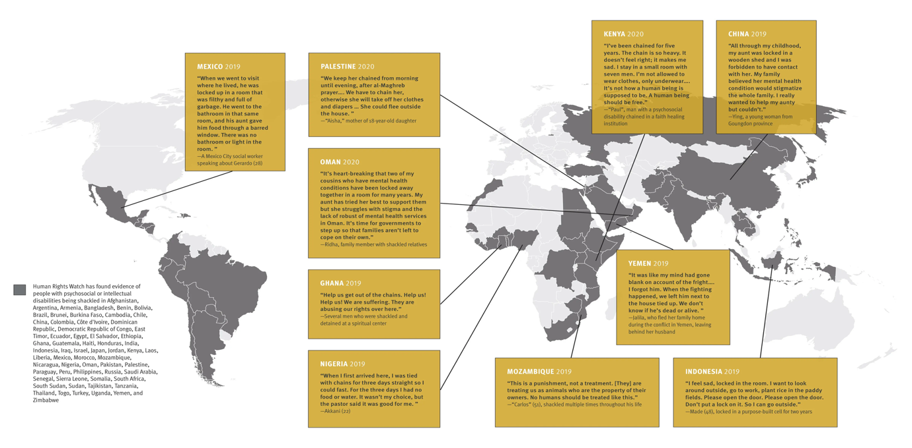
The impact of shackling is clearly seen from various statements made by those who have suffered from it. Made, a man with a psychosocial disability, was locked up on his father’s land for two years in Bali, Indonesia. He said, “I feel sad, locked in this cell. I want to look around outside, go to work, plant rice in the paddy fields. Please open the door…Don’t put a lock on it”. In Kenya, Paul was chained in a faith-healing institution. He commented, “I’ve been chained for five years. The chain is so heavy, it makes me sad…I’m not allowed to wear clothes…I have to go to the toilet in a bucket…It’s not how a human being is supposed to be. A human being should be free.”
A map of the nations Human Rights Watch have found the practice of shackling occurring in.

With the right support, those with mental health conditions can thrive. In Tanzania, an intellectually disabled boy named Malachie was chained to a pole by his family to ensure his safety in a refugee camp. When the Special Olympics team freed him, he got the opportunity to start playing football. After a lot of hard work, he was selected to participate in the 2019 Special Olympics World Games. By doing this, he helped shape his community to be more inclusive and accepting, and to get rid of their underlying stigma about psychosocial disabilities.

Areas of discussion:
- What can the UN do to prevent shackling taking place?
- How can the UN strengthen legislation and international collaboration regarding the eradication of shackling?
- How can the UN assist developing nations in replacing shackling with community-based care?
- What sanctions should the UN put in place for nations that refuse to comply with the legislation implemented?
- How can the stigma surrounding psychosocial disabilities be combatted?

Further Reading:
https://resourcecentre.savethechildren.net/pdf/global_shackling1020_web_0.pdf
https://www.hrw.org/report/2020/10/06/living-chains/shackling-people-psychosocial-disabilities-worldwide
https://www.aljazeera.com/features/2020/10/10/rights-group-mentally-ill-shackled-and-chained-worldwide

