The Issue of Pandemic Preparedness
Pandemics are defined as an international epidemic across multiple countries normally affecting a large number of people. Some of the most recent pandemics in history that have had a great effect globally include HIV, 2009 H1N1 Influenza and most importantly COVID-19 which managed to expose the many weaknesses in global and national systems.
The spread of coronavirus meant countries worked independently and lacked valuable trust, transparency, and communication between nations. This lack of clarity and misinformation online caused confusion that helped Covid spread when it came to abiding to the rules.

Another inequality that was highlighted was access to vaccines and treatment where high-income and low-income countries had different struggles. Many countries’ health systems were unprepared and underfunded for the sudden increase in treatments as well as helping to find a vaccine.
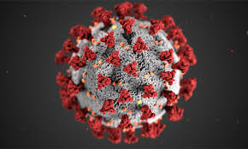

What diseases pose the greatest threat?
Zoonotic disease poses the greatest threat of pandemics with 9% of Earth land area posing high or very high risks of an outbreak. Zoonotic diseases are transmitted from host animal to human through contact with saliva faeces or blood. Key examples include: Zika virus, Marburg virus, Lassa fever, Crimean-Congo haemorrhaging fever and MERS-CoV. The highest risk disease is Influenza which annually has a 1% probability of an influenza pandemic that’s causes 6 million deaths.
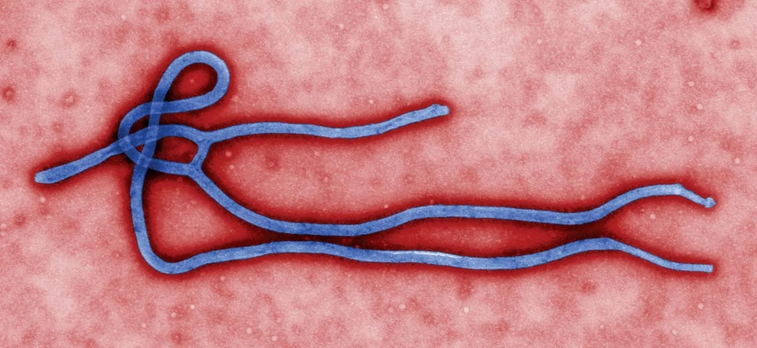

Risk factors for Zoonotic diseases are:
- Annual maximum temperature
- Annual minimum temperature
- Water deficit
- Annual total rainfall
- Livestock density
- Human population density
- Change in proximity between humans and forests
- Biodiversity loss.
Why is pandemic risk high currently?
It has been estimated by the centre of global development that annual pandemic risks are 2/3% and there is a 47–57% chance of another pandemic in the next 20 years. This is due to high spark risk zones like Central and Western Africa lacking developments in pandemic preparedness necessary to control a localised outbreak. Also changing migration patterns of disease carrying vectors leads to a break down of geographical isolation of species and increased risk of spillover infection (reservoir species meets a novel host population).

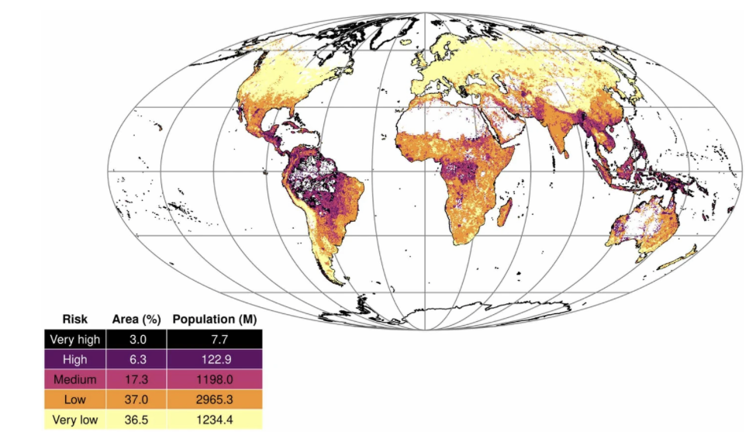

https://www.carbonbrief.org/climate-change-is-creating-new-vulnerabilities-for-disease-pandemics/

Key questions to address
- How could policy-markers ensure for distribution of correct and comprehensive information during a pandemic?
- How could preparation consider different groups have different means and ability to follow guidance?
- How could more transparent global communication channels to be developed to ensure awareness of methods of spread?
- How can inequality and the disparity in ability to treat and mitigate spread be managed between countries.
- How can countries prepare their own healthcare systems including front line treatment as well as supply of necessary resources.
- How can technological advancements of genetically engineering and artificial intelligence act to reduce pandemic risks in the future ?
- Does antibiotic resistance pose further risks and if so how can these can be mitigated ?

