The Issue of the Politicisation of Immigration and its effect on International Co-operation

Chair: Fayaz Alam

In recent times, the politicisation of immigration has become a notable issue with regards to its impact on international co-operation. As rhetoric and opinions on immigration have become increasingly polarised, particularly with the rise of far-right groups, parties and governments since the dawn of the 2020s, relations between international bodies and states have begun to deteriorate significantly, with hope for reconciliation on this issue waning. Therefore, it is of utmost importance that delegates strive to maintain diplomacy when considering the political effects of immigration on global co-operation in today’s era of fragmenting international relations.

Currently, there are a multitude of different countries that are either under the leadership of governments promoting anti-immigrant rhetoric and/or have major opposition parties that are gaining support amongst their nation’s population. An example of one of these nations may include the USA, which is currently run by a rather reactionary government under President Trump, with Trump's own election campaigns in 2016 and 2024 in part being built around prominent immigration messaging surrounding Mexico and other Latin American countries. Additionally, countries such as Italy and Hungary, who have felt the strain of migrant influxes in the past, are now exercising harsher and tougher immigration laws to slow the influx of immigrants and refugees. All of the aforementioned countries, amongst others, are well-known for disseminating strongly anti-immigrant rhetoric both at the national and international level, often sparking disagreements and disputes between them and their regional neighbours.


On the other hand, there are also nations which promote or have a more nuanced view of immigration as a whole rather than adopt hardline policies and rhetoric against it. Perhaps the most notable of these countries is Germany, which historically has been welcoming of immigrants and asylum seekers, particularly during the 2015 European Migrant Crisis where they accepted 2.14 million immigrants and around 1 million asylum seekers (although currently there are some talks of deporting Syrian refugees from Germany on the basis that the civil war in Syria has come to an end). Also, countries such as France and UK have been accepting towards immigrants in the past and still are, although balancing this immigration policy along with the rampant rise of far-right/anti-immigrant parties such as the National Rally (France) and Reform (UK) respectively in public opinion polls has complicated their attitude towards migrants as of late.
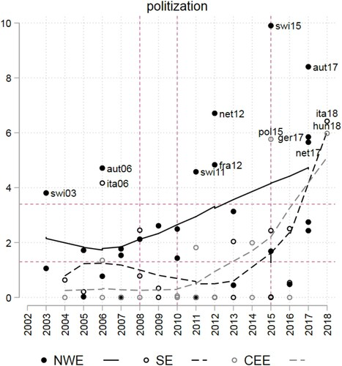
In addition to rhetoric and opinions surrounding immigration, many countries also politicise immigration through threats of migration floods. This is where a country with a large population of refugees threatens to open their borders and release massive waves of migrants into a neighbouring country or continent, often with the intent of destabilising rivals in order to obtain political or financial gains. Countries such as Russia and Türkiye are the biggest proponents of this method, channelling migrants from the Middle East and Africa into neighbouring EU countries such as Poland and Greece, straining EU security and pressuring them for political concessions. And in a similar vein, countries such as the USA are actively deporting swathes of migrants (over 1 million people since the start of 2024) back to their home countries; this is despite weak bilateral measures being in place to ensure accountability and clarity for the states involved in such projects, further endangering international co-operation.

So far, the UN has made limited progress on strengthen international co-operation in relation to the discussion of immigration and its political effects. Whilst UN-sponsored international bodies such as the UNHCR have verbally condemned the leveraging of anti-immigrant sentiment and usage of anti-immigrant rhetoric, nothing of major multilateral substance has successfully been produced to tackle the politicisation of immigration effectively, especially with recent developments over the past decade. In particular, there is little to no international legislation on modern day issues relating to immigration such as anti-immigration rhetoric and manufactured migrant floods.

Delegates should consider:
• Balancing national sovereignty with strengthening international co-operation
• Anti-immigration rhetoric, particularly for its usage to gain electoral success
• Preventing the weaponisation of migrants for political/financial gain
• The role of regional blocs such as the European Union, and whether they help or hinder discussion in regards to the global political outlook on immigration
• The bilateral impacts of returning migrants back to unwilling, hostile nations via mass deportations
• The unjust place of discrimination, xenophobia and identity politics in global immigration discussion

Optional further reading:
*shortest to longest

https://emerging-europe.com/analysis/un-expresses-concern-over-politicisation-of-migrants-in-hungary/ (https://emerging-europe.com/analysis/un-expresses-concern-over-politicisation-of-migrants-in-hungary/)

US ‘Seriously Concerned’ by ‘Weaponized Migration’ From Belarus, Calls Mass Migration ‘Existential Threat’
(https://www.kyivpost.com/post/64903)

https://migrationpolicycentre.eu/international-cooperation-migration-have-centrifugal-centripetal-influence/

https://www.tandfonline.com/doi/full/10.1080/1369183X.2020.1853902
(very long, very optional read)

