KSCMUN Conference- the issue of the use of social media within the youth, and should it be banned for under 16s
Social media is developing every day, from apps like instagram to tiktok and around 90% of teens are currently on these apps up to 3 hours or more a day. Social media has hundreds of creators who have certain types of content, which some people may consider harmful. Idolising these influencers and creators gives their audiences an identity or a role model to look up to.
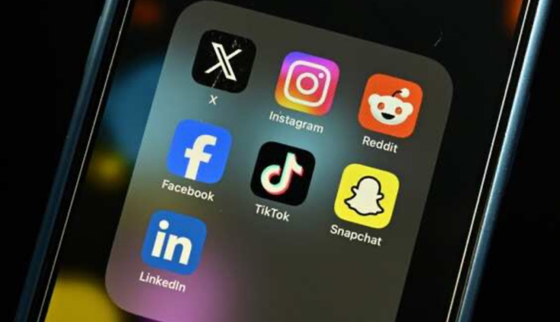
One major concern is the influence of social media creators on young audiences. Due to recommendation algorithms, young users may be repeatedly exposed to content created by individuals who promote harmful or inappropriate messages. In some cases, content has been criticised for promoting sexist attitudes, aggressive behavior, or unhealthy body images, which may negatively affect teenagers’ mental health and social development. Also, there has been concern about the amount of explicit content that young people see circulating on platforms like google, Reddit and X (previously twitter).
Additionally, some creators with large teenage followings have faced controversy for inappropriate contact with underaged fans, highlighting weaknesses in online safeguarding and age-verification systems. These cases have increased international debate about whether current regulations are sufficient to protect minors online.
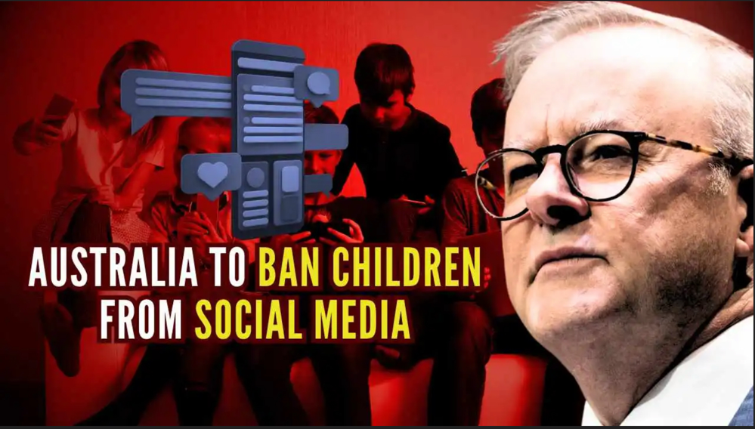
As a result, governments and international organisations are considering policy responses such as stronger content modifications, improved community guidelines, and better age verification to reduce the risks associated with social media usage among young people. An example is Australia’s under 16s social media ban. But some may disagree with this as social media platforms create places to express yourself creatively and communicate with other people.
Some ideas for delegates to consider:
- How can we stop harmful content from circulating?
- Should we limit the addictive design features in social media? Would this help?
- Does social media show signs of giving people mental health issues?
- Should governments focus on making the guidelines and safety features strange or just a general ban in total?

Useful links:
https://www.bbc.co.uk/news/articles/c8x40qplk15o

